**HTML Assignment**

**Name: Syed Muhammad Bin Khalid Zaidi**

**Definitions and Terminologies**

**Company Name: Brain-Nest**

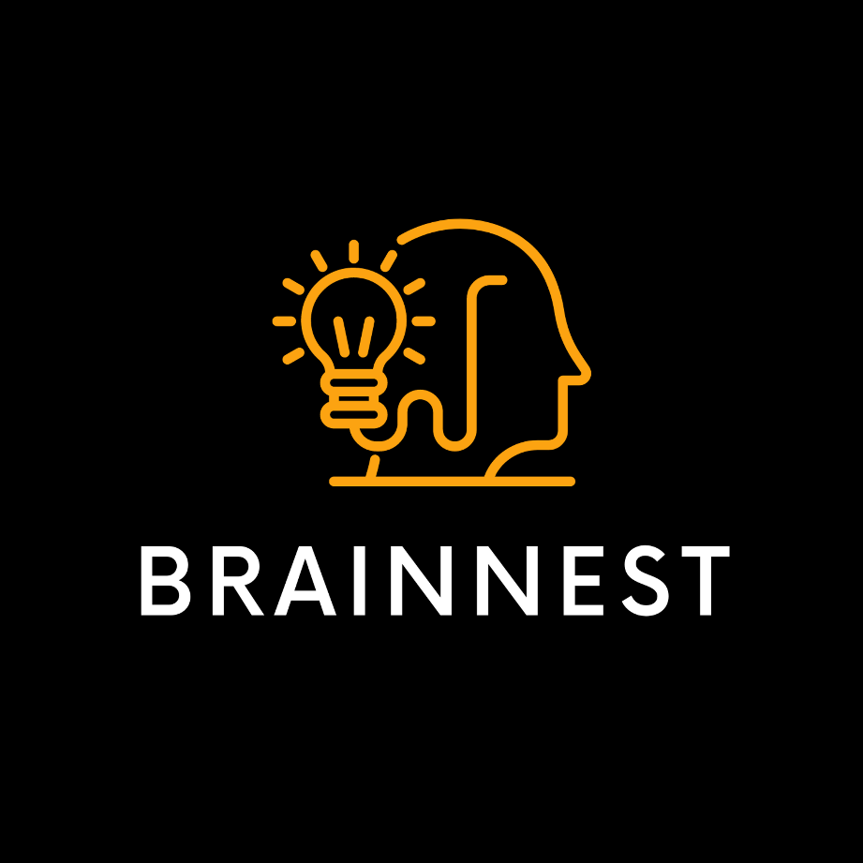

**HTML Assignment**

**Question No. 1**

What do HTML and CSS stand for?

**Answer:**

HTML: Hyper-Text Markup Language

CSS: Cascading Style Sheet

**Question No.2**

Would you rather use HTML or CSS, for putting paragraphs of text on a webpage?

**Answer:**

HTML would be used for that purpose.

**Question No.3**

Would you rather use HTML or CSS, to change the font and background color of a button?

**Answer:**

Css would rather be used for that purpose.

**Question No.4:**

What is an HTML tag?

**Answer:**

HTML tag is something that is used to define a specific property

related to a specific element. The **examples** of the tags are given below:

<!DOCTYPE> Defines the document type

<html> Defines the root of an HTML document </html>

<title> Defines a title for the document </title>

<header> Defines a header for a document or section </header>

<main> Specifies the main content of a document </main>

<footer> Defines a footer for a document or section </footer>

**Question No.5:**

What are the three parts of an HTML element? (image from paragraph)

**Answer:**

An HTML element consists of a start tag, some text (body) and an end tag.

**Question No.6:**

What is the purpose of the doctype declaration?

**Answer:**

<!DOCTYPE> Defines the document type

**Question No.7:**

What is the HTML element?

**Answer:**

An html element consists of three main parts:   
1). A start tag

2). An end Tag

3). And some content/text in the middle of these tags.

An html element can contain children elements. And mainly maintains the structure of the code and adds semantics and formatting to parts of document. Each element can have specified attributes owing to their specific tags.

**Question No.8:**

What is the purpose of the head element?

**Answer:**

<header> Defines a header for a document or section </header>

**Question No.9:**

What is the purpose of the body element?

**Answer:**

<body> Contains the body of the document. The <body> element contains all the contents of an HTML document, such as headings, paragraphs, images, hyperlinks, tables, lists, etc.

**Question No.10:**

How do you create a paragraph in HTML?

**Answer:**

Using the <p> and </p>(end tag) tags. We can easily create the paragraphs in HTML.

**Question No.11**

How do you create a heading in HTML?

**Answer:**

Headings can be created using the <h1>, <h2> and following the subsequent tags. As you go down the order starting from 1. The size of the heading decreases as a result.

**Question No.12**

How many different levels of headings are there and what is the difference between

them?

**Answer:**

Headings can be created using the <h1>, <h2> and following the subsequent tags. As you go down the order starting from 1. The size of the heading decreases as a result.

**Question No.13:**

What element should you use to make text bold and important?

**Answer:**

The element used to make text bold and important in html is <strong>.

**Question No.14:**

What element should you use to make text italicized to add emphasis to it?

**Answer**

To italicize the text in HTML, use either the em tag or the i (italics) tag. Both of these tags will italicize the text, but the em tag additionally indicates that the text has stress emphasis when read.